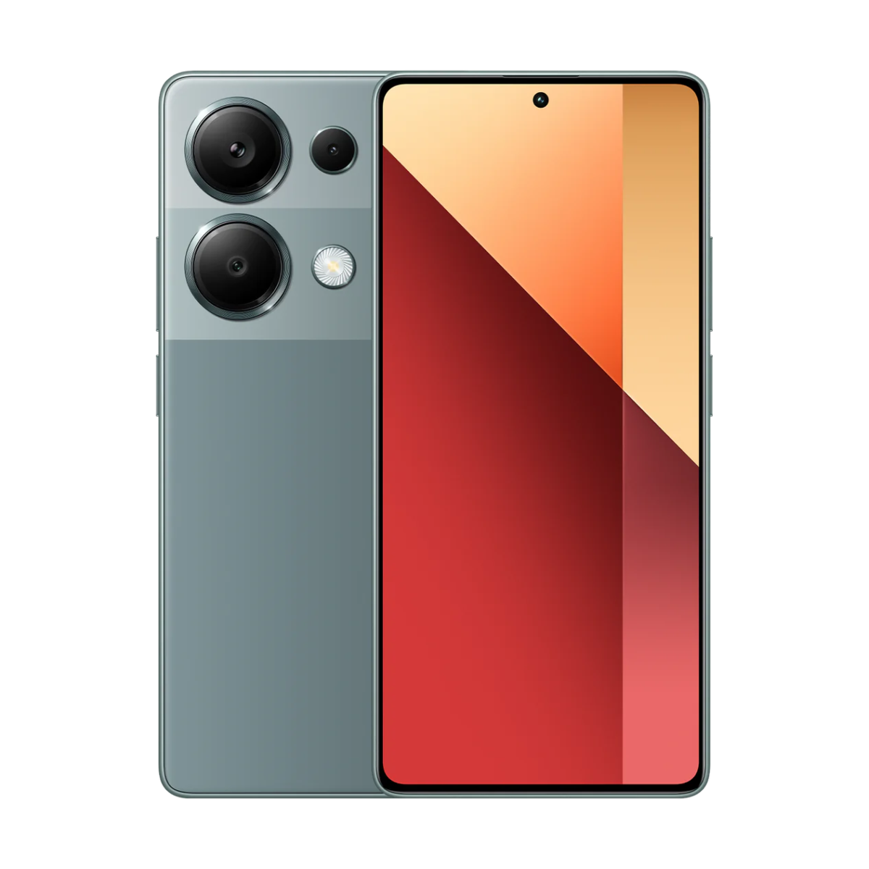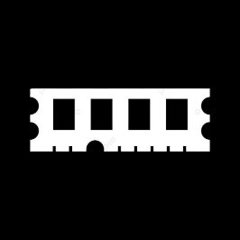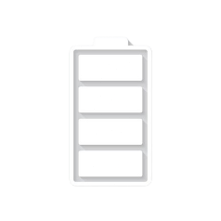

Redmi 13

* Processor: Mediatek Helio G91 Ultra (12 nm)
* Front Camera: 13 MP
* Rear Camera: 108 MP
* Display:6.79 “
* NFC:Yes:
* ColorsMidnight Black, Sandy Gold, Ocean Blue, Pink
* Operating System:
* Android 14
* Charging Type: USB Type-C
* SIM:Nano-SIM,Esim
* Fingerprint:Yes
* Release Date: 2024, June 03

Price: $148

RAM

8

GB

ROM

256

GB

BATTERY

5030

mAh



+001-28272300-2466-2469



webmaster@cellinfo.com



A-65, ACME Co. ,

Street No. 12,

New York

Ask Me Ltd.